DC Senior Tech Assessment:  
  
Ugochi L Ndubuisi.  I'll be brief and concise.  #1.  **Pending Inquiry checks**.  No one does it, or know how perform.  I can guide you through screenshots, or in person, which is the faster way.  There are many incomplete tests received in lab and not done.  The TAT monitor will not show Routine pending tests.   A reply from Ingrid will not do.

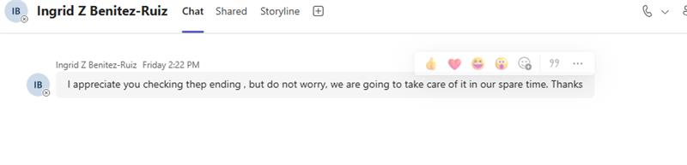

#2.  **Inventory/Supplies** checking, ordering system is **Inefficient**. Techs run out of reagents, have to borrow, the last minute.  Causes test delayed and unnecessary Stress calling other labs, time spent away from the bench. Costs in Stat Courrier Services.

Here is our list of IOU's for items lent to Largo.

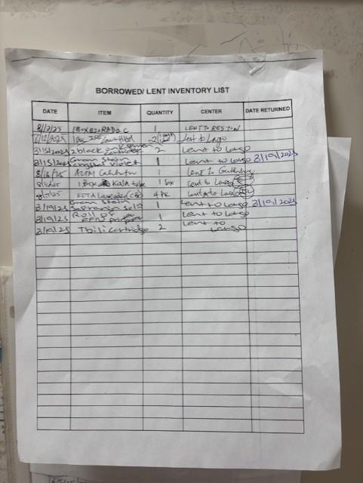

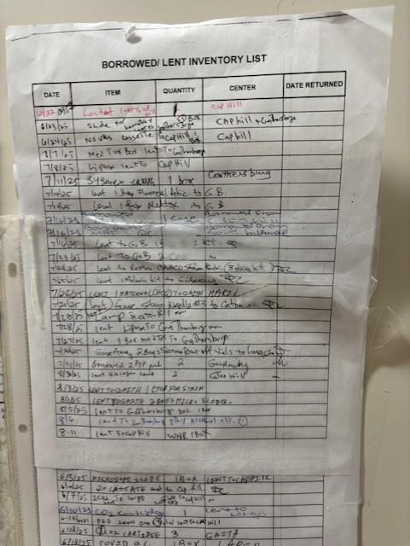

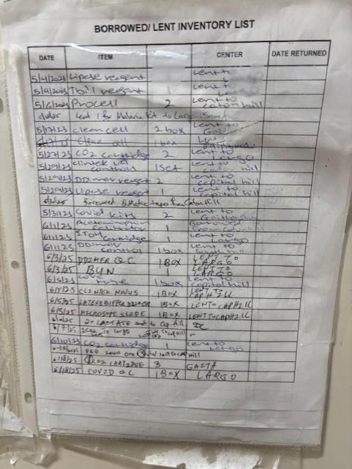

#3.  List of **Duties/Expectation/Workflow schedule**.  Anyone who comes in the lab, floaters should know exactly what to do.  There should be a list.  What time QCs, maintenance items needs to be done, MOB lab, AUC lab for each shift.    I have saved a sheet from my previous manager.

